**Project Name:** Calorie Calculator

**Github Link:** https://github.com/utkrisht2000/Calorie-Calculator.git

**Why was this project created?**

We have probably heard the saying "health is wealth" a thousand times, but as we age, we frequently come to realize that it is true. This app offers a fun approach to begin the extremely dull process of dieting, even though we all know that FITNESS BEGINS WITH WHAT WE EAT.

**What problem is it solving?**

To determine how many calories a person needs to consume each day, use the calorie calculator. Additionally, this calculator can offer some basic tips for gaining or reducing weight. If you're attempting to lose, maintain, or even gain weight, calorie counters and nutrition trackers can be quite helpful. They can also assist you in making particular dietary adjustments, such as consuming more protein or less carbohydrates.

**Entire explanation of project**

* **TECHNOLOGIES USED**

1. Python
2. HTML
3. CSS
4. Bootstrap
5. Django framework

* **PROPOSED APPROACH**

We will require the model in order to access databases. Make these models in CalorieTracker/models.py. Our model will record: Clients, the whole food selection, Consumed food items are a category of food products. For that, we are employing basic model fields. The client and the admin won't be able to view each other's data thanks to this taking care of all access privileges. Additionally, it will ensure that users who are logged in cannot view the login and registration pages and that only authorized users can access those pages. Your login, email, and password will be required. In order for it to ultimately contain, we must first create a new file called urls.py in our project.

In the outside project folder, we must create a new static folder. To do this, we must edit setting.py, add the phrase "% load static%" to our templates, and create a new file named main.css in the static folder. We were able to construct the calorie calculator Python project in Django effectively, and we can now use it daily to monitor what we eat and how much we ought to eat.

Algorithm for creating next word prediction model :

**Step 1:** Create Django Project

**Step 2:** Create Sqlite Database

**Step 3:** Design the Template

**Step 4:** Manage the views.py, urls.py, admin.py etc.

**Step 5:** Make Migration

**Step 6:** Runserver & Register the User

* **DATA FLOW DIAGRAM**

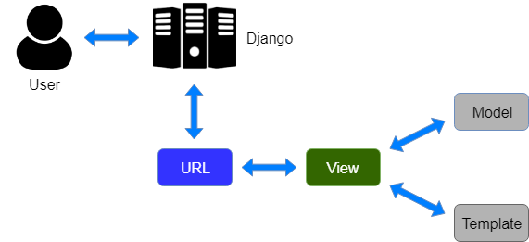

* **RESULT**

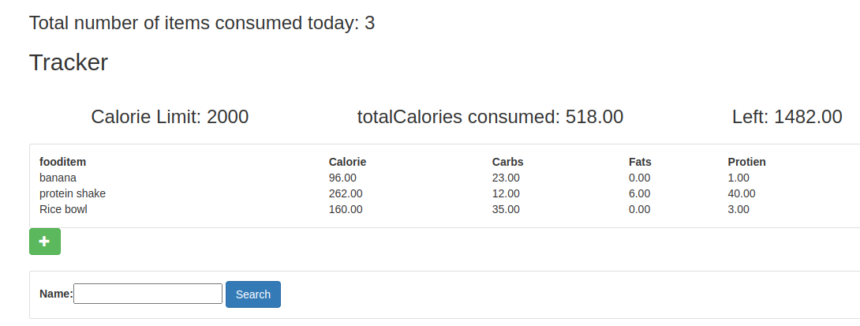

* **CONCLUSION**

The WebApp was created using Angular and Django Framework, which enables cross-platform compilation. Because the programme doesn't require any additional hardware to work, it is thought that it will encourage healthy living among the common person. For user convenience, this project has been made available as a webapp application. However, it would be profitable for such platforms to be exploited given the quick increase in the adoption of less expensive fitness bands. Greater portability and accessibility for a larger variety of people would result from this.